WEB DEVELOPMENT

ACTIVITY-BASED LEARNING

Submitted by: Chiruguri Harini

Course: B.Tech – Artificial Intelligence and Machine Learning

Projects:

1. Flower Shop Website
2. Pet Care Center Website
3. Bakery Website

1.Flower Shop Website
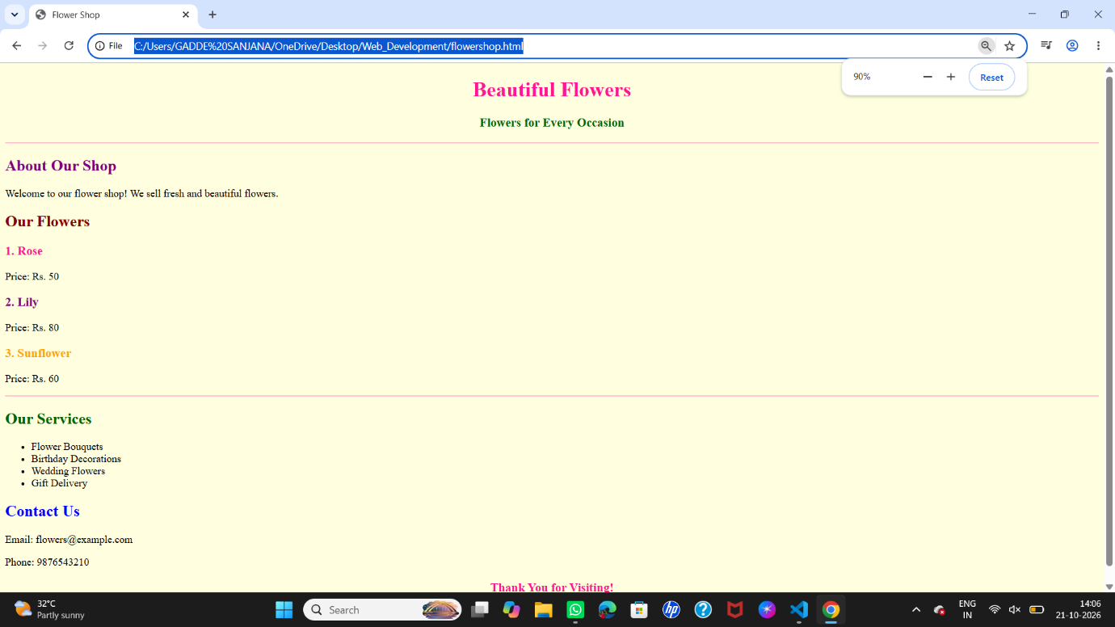

2.Pet Care Center Website


3.Bakery Website
